Software Requirements Document for “Order and Delivery management system”

Author: Group 8
Amangeldiyev Amantur
Batarayev Rassim
Khassanov Daniel
Koktalov Dastan

Version | Date | Author | Change
0.1 | 24/02/14 | Group 8 | Initial Document

Table of Contents

1 Introduction 3
1.1 Purpose 3
1.2 Scope 3
1.3 Definitions, acronymns, abbreviations 4
1.4 References 5
1.5 Overview 5
2 Overall description 6
2.1 Product Perspective 6
2.2 Product functions 8
2.3 User characteristics 25
2.4 Constraints 25
2.5 Assumptions and Dependencies 25

Introduction

Purpose
The purpose of this document is to provide detailed requirement information about the “Order and Delivery management system”. Our system is created for companies, which want to add online ordering feature.

Scope
This document will describe the use cases and features of the “Order and Delivery
management system”

Definitions, acronymns, abbreviations
Term | Description
Administrator | The owner of company, who can control everything and everyone in desktop app
Courier | Worker of company, who will deliver orders to users
Manager | Man, which is staff of company, and which can control orders through desktop app
Order | Order, which is made by user, through web site
System | Group of solutions, which consists of Database, Web application and Desktop application
User | Someone, who visits website and makes order

References
[OMIT]

Overview
[OMIT]

Overall Description

The “order and delivery management system” is a whole system, which can implement in any café functions, which will allow customers to buy meals online. Also it will give abilities to managers to control orders from users, and will log all operations for administrator, who can check his staff for conscientiousness.

Product Perspective
This system is similar to many systems, that exist in different companies, but our system is much convenient, than others, cause it will be flexible enough. This system can be installed in any company, it will not ask big requirements. It’s uniqueness that it is universal and requirements are very low. Our target audience are cafes and restaurants, which do not currently have online ordering system.

Concept of Operations
“Order and delivery management system” will be based on multiple technologies. Our web site will be written on PHP, our desktop application will be written on Qt, and our optional mobile app will be written using android framework. All this components will be connected through one MySQL database, which will be hosted online.

Major User Interfaces
See Appendix A

Example Screenshot and description
See Appendix B

Hardware Interfaces
Web site requires no more than standard personal computer peripherals.
Desktop app also requires no more than standard personal computer peripherals, but it will be more comfortable to managers, if they will use monitors with touch screen.
Android app will require any working android devices, with internet connection.
Central MySQL database will require server with static IP address and with stable power, this paragraph will be provided by us.

Software Interfaces
// example: CGI-URL or function signatures etc (OMIT for now).

Communication Interfaces
// example: modem etc (OMIT for now)

Memory Constraints
// RAM, and other storage constraints (OMIT for now)

Operations
// special operations (if any) (OMIT for now)

Site Adaptation Requirements
//ex: Japanese language etc (OMIT for now)

Product functions
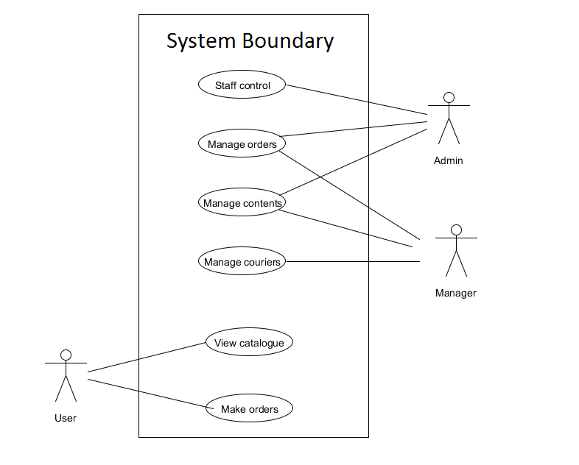
This use cases diagram shows us all abilities of all users of our “Order and delivery management system”. Users can view catalogues and make orders, managers can manage couriers, contents of site and orders, admin can manage contents of site, orders, and staff.

Viewing online catalogue

Pre-condition: Internet browser with active internet connection

This use case describes situation when someone wants to view available meals in company which has our system installed

Actor: User

User enters website, to view online catalogue

User selects category in which he is interested

Users selects product in which he is interested.

Small info about product and quantity selection screen appear

If user selects other product – current info and quantity selection screen will disappear, and new info and quantity selection screens will appear.

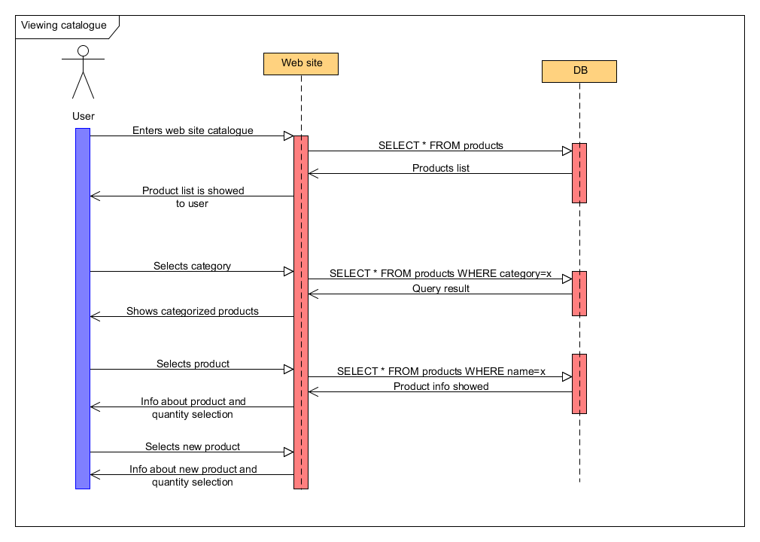

Making order

Pre-condition: Internet browser with active internet connection

This use case describes situation when someone wants to order online any of available meals from company which has our system installed

Actor: User

User enters website

User selects wanted product from catalogue

Selected products go to shopping cart

User goes to his shopping cart and fills out all info about delivery

User gets message about order status and exits from site

If everything gone ok, user receives his meals and pays money to courier

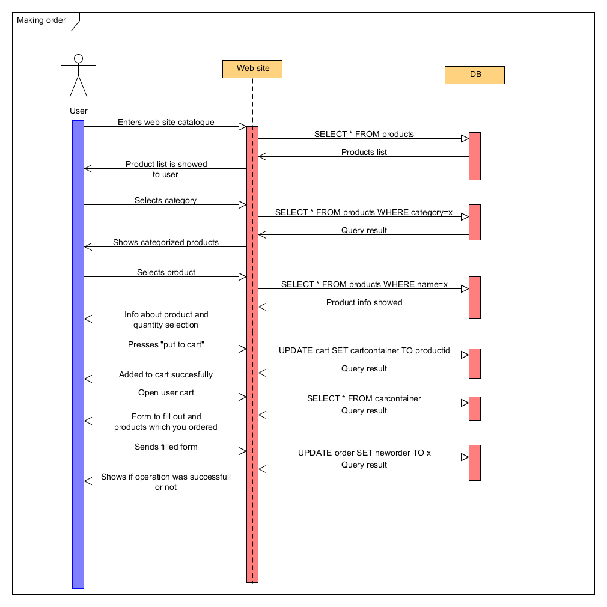

Viewing couriers

Pre-condition: Desktop application with active internet connection

This use case happens when manager or administrator wants to view all courier’s statuses

Actors: Manager and Administrator

Actor navigates to order management window through “Delivery” button

Window with courier info and status appears

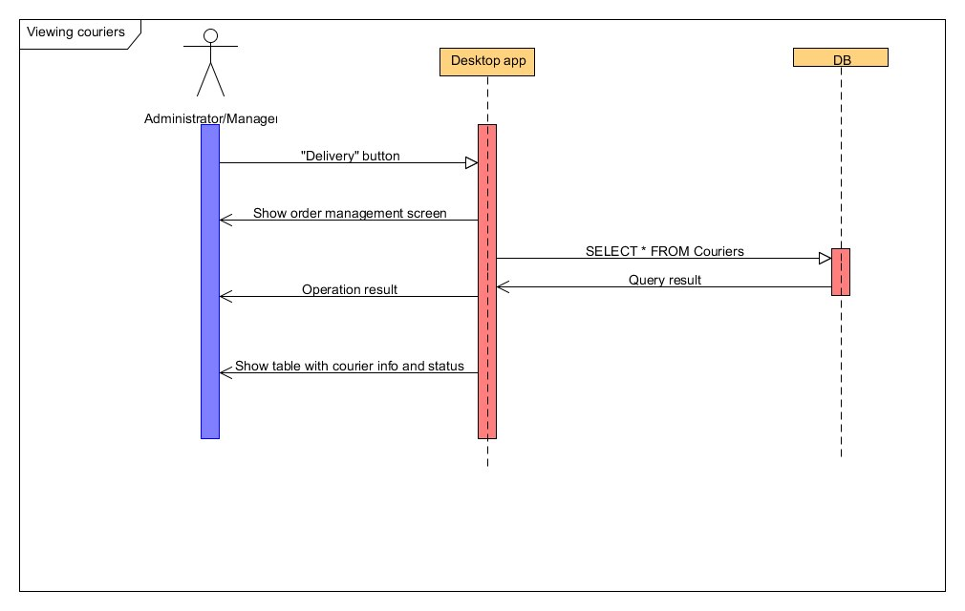

Staff control

Pre-condition: Desktop application with active internet connection

This use case happens when administrator wants to add, edit, or remove staff of his company

Actor: Administrator

In application through “staff” button he navigates to screen, with all staff of the company and their info

He can delete or add staff or edit current staff’s information

To delete staff administrator must press “delete” button, and selected staff will be deleted from database

To edit staff he must press button “edit” in lower right corner of that person, which he want to edit

In new opened window he should change info, which he needs to change and press “Save” to save, or “Cancel” to rollback actions

In order to add new staff he must press “add staff” button

In new opened window he must enter all needed info and press “save” button

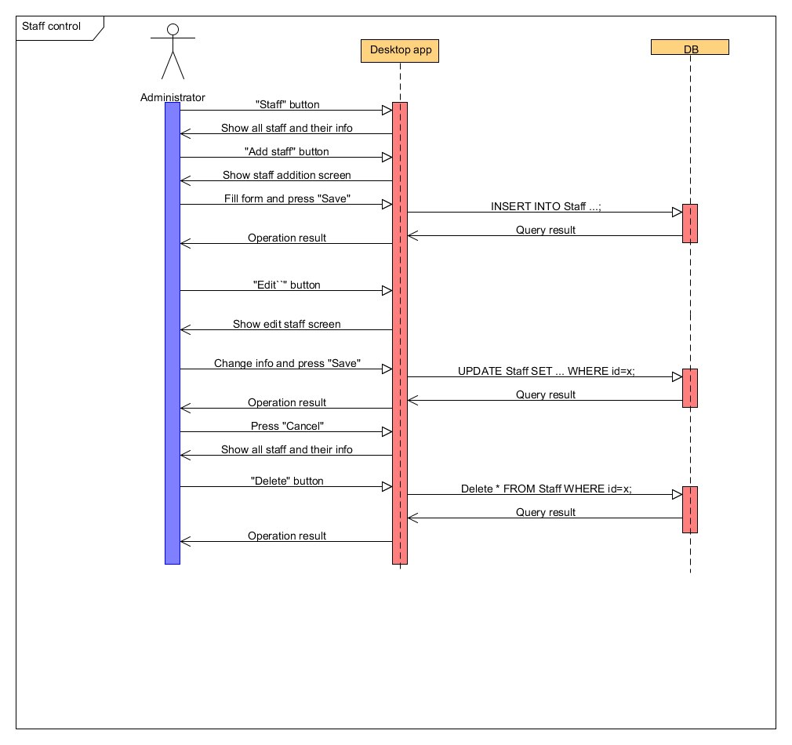

Administrator managing content

Pre-condition: Desktop application with active internet connection

This happens when administrator wants to add, edit, or remove products, which are showed in online catalogue

Actor: Administrator

Administrator presses “Manage content” button to navigate to content management screen in application

If administrator wants to add product, then he must press “Add product” button and navigates to product addition screen

Then administrator fills form and presses “Add” button to add product, or “Cancel” button to go back to content management screen

Administrator receives acknowledgement if operation completed successfully or not

If administrator wants to edit content, then he must press “Edit” button and goes to screen which will allow product edition

Then administrator fills form and presses “Edit” button to apply changes, or “Cancel” button to go back to content management screen

Administrator receives acknowledgement if operation completed successfully or not

If administrator wants to delete content, he should press “Delete” button

Administrator receives acknowledgement about status of operation

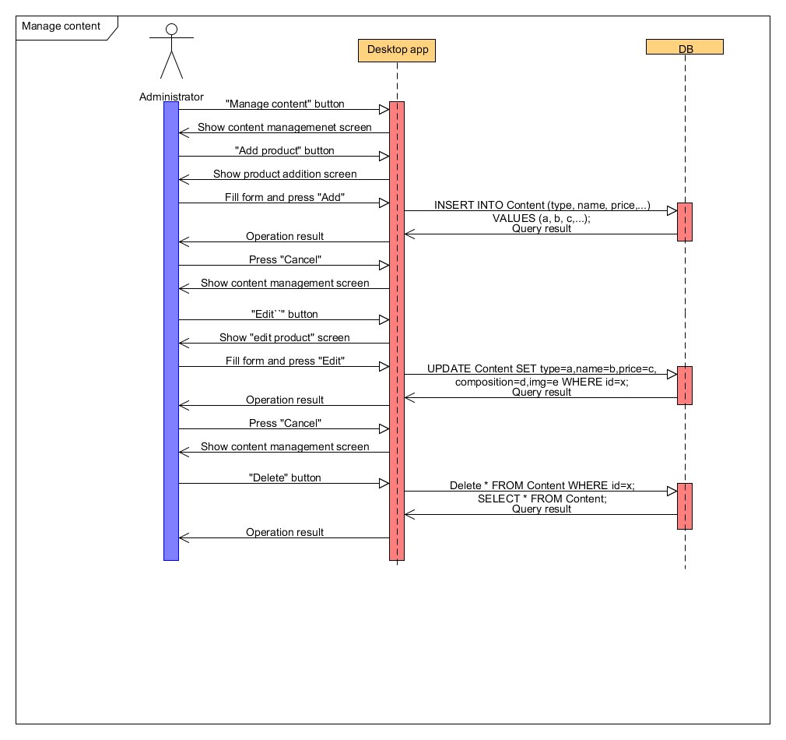

Manager managing content

Pre-condition: Desktop application with active internet connection

This use case usually happens when manager wants to add, edit or delete products from online catalogue

Actor: Manager

Manager presses “Manage content” button to navigate to content management screen in application

If manager wants to add product, then he must press “Add product” button and navigates to product addition screen

Then manager fills form and presses “Add” button to add product, or “Cancel” button to go back to content management screen

Manager receives acknowledgement if operation completed successfully or not

If manager wants to edit content, then he must press “Edit” button and goes to screen which will allow product edition

Then manager fills form and presses “Edit” button to apply changes, or “Cancel” button to go back to content management screen

Manager receives acknowledgement if operation completed successfully or not

If manager wants to delete content, he should press “Delete” button

Administrator receives acknowledgement about status of operation

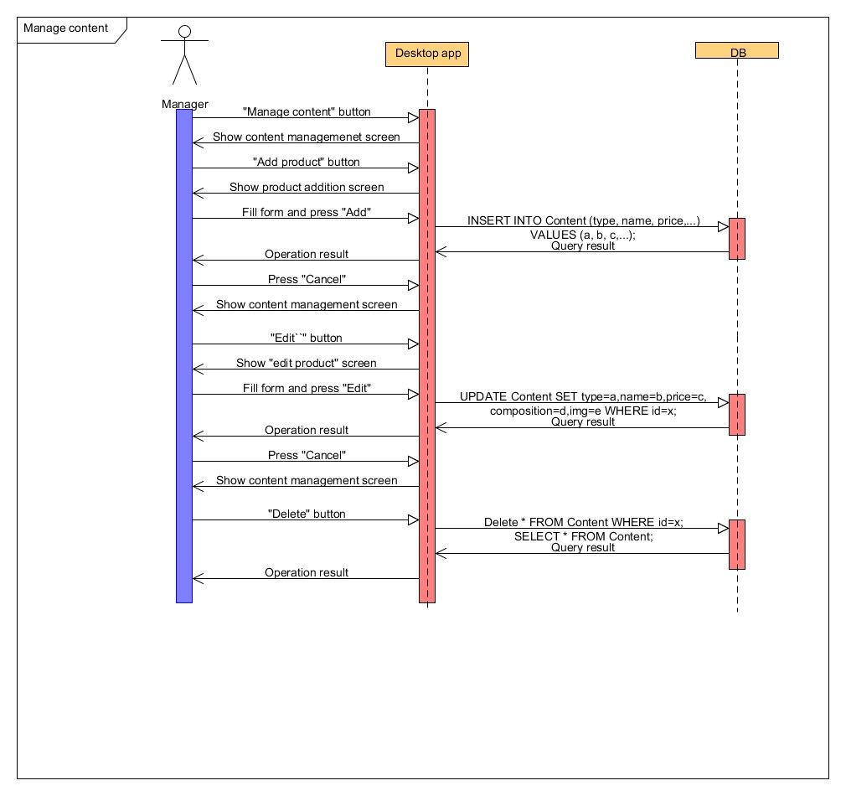

Manage Orders(manager)

Pre-condition: Desktop application with active internet connection

This case usually happens when manager wants to manage orders (accept or decline)

Actor: Manager

Manager will press “Orders” button and will be navigated to manage orders menu in application.

There he will see table of orders, accept and decline buttons, logout button, back button.

For going back to main menu he will press back button.

If manager want to decline the order he will press “Decline” button then order will be declined.

If manager want to accept the order he will press “Accept” button then he will be navigated to courier assignment window.

In courier assignment window manager will see table and accept button.

He will choose courier and press “Assign” button.

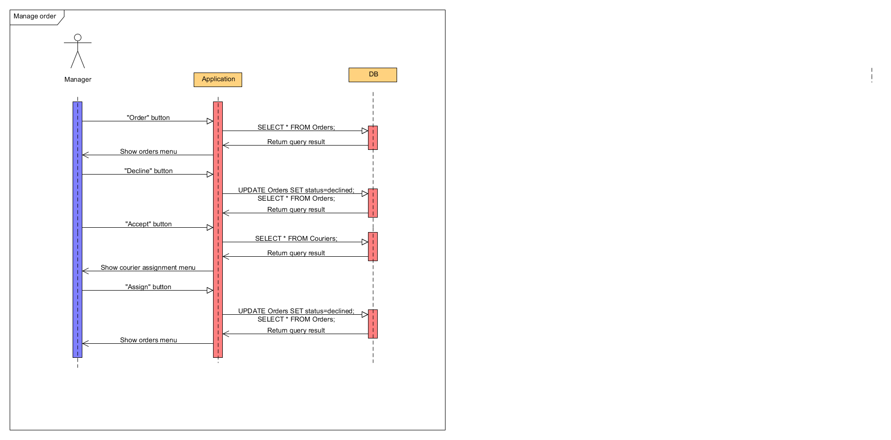

Orders (administrator)

Pre-condition: Desktop application with active internet connection

This use case happens when administrator wants to view history of orders

Actor: administrator

Administrator will press “Orders” button and will be navigated to orders menu in application.

There he will see table of orders, statuses of orders, logout button, and back button.

Here he can see which orders been declined, accepted or been unanswered.

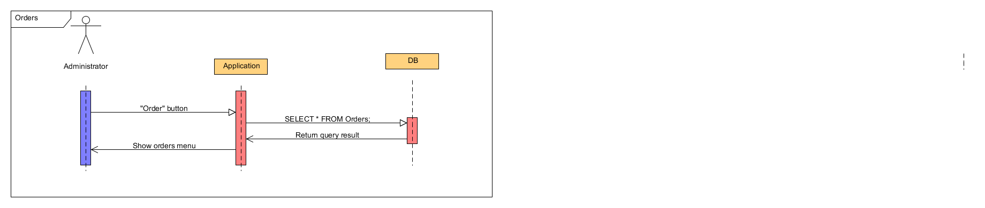

User characteristics
Types | Characteristics | Frequency of usage
User | Has ability to see catalogue and order meals | High
Manager | Has ability to change content of site, manage orders, manage content of site and manage couriers | High
Administrator | Has ability to see history of orders, manage content of site and manage staff | Med

Constraints
- Our web site is used by various users, so it has to be very minimalistic and easy to use and understand.
- On customer side has to be installed our application for managing site and orders.

Assumptions and Dependencies
- Desktop application must be installed on customer side. So managing everything depended on desktop application.

Features
- Login
- Managing content of site
- Managing orders
- History of orders
- Staff managing
- Viewing catalogue
- Online ordering meal

